Mr. Ahsan Pardesi,
Hon'ble Member of Legislative Assembly,
Lal Chowk Constituency,
Srinagar, Jammu & Kashmir.

No: KGP/Estt/2026/559 Dated:29-06-2026

Subject: Urgent Request for Immediate Provision of 4 Hot & Cold Commercial Water Purifiers.

Respected Sir,
With reference to the above-captioned subject, I am writing to you on behalf of Kashmir Government Polytechnic College, Srinagar, one of the premier and oldest technical institutions in Kashmir, imparting quality technical education since 1960. The Institution is presently catering to more than 900 students, out of which more than 300 students are residing in the Boys and Girls Hostels. These hostel students largely belong to far-flung areas and most of them come from economically weaker sections of the society.
Safe, pure and hygienic drinking water is of paramount importance for the health and well-being of our students. In view of the substantial student strength and their continuous requirement of drinking water, we are in urgent need of additional water purification facilities.
We, therefore, most humbly and respectfully request your kind and immediate personal intervention for the provision of 4 (Four)Hot and Cold Commercial Water Purifiers for the institution. This support will greatly help us in ensuring that all our students have access to clean, safe, and temperature-appropriate drinking water at all times.
We shall be highly obliged and sincerely grateful for your benevolent support and prompt assistance in this matter of urgent necessity.

Thanking you in anticipation.

Yours Faithfully

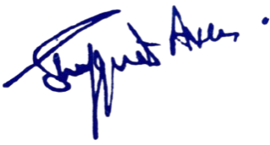

Principal
Kashmir Government Polytechnic College
Srinagar

